Embassy of India, Moscow
Embassy car for sale
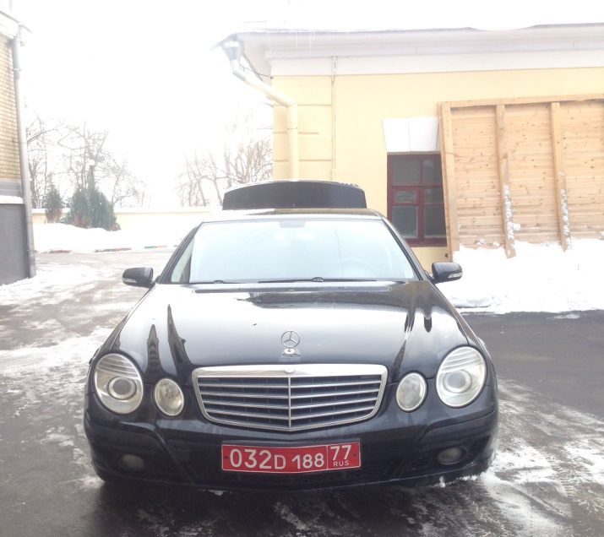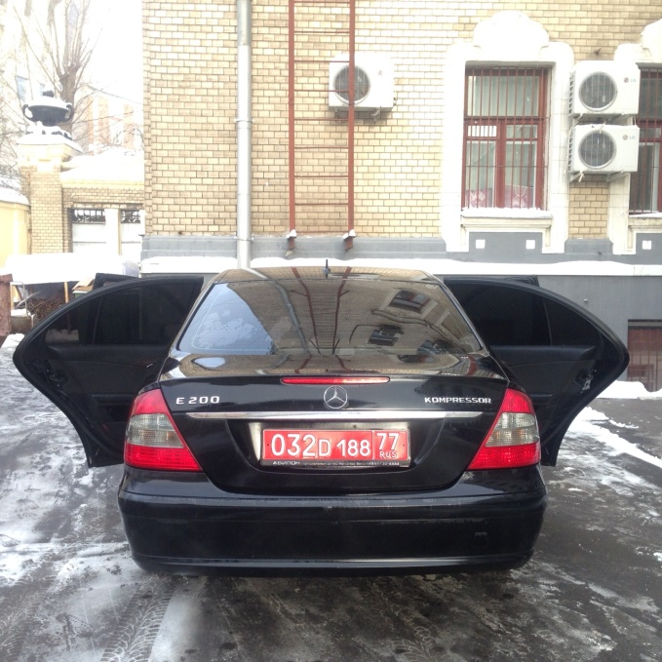
Model | Mercedes Benz E 200
Year | 2009 (Jan)
Colour | Black
Mileage | 182850
Transmission | Automatic transmission
Condition | Good
No. of Winter Tyres (Purchase Year) | 4 (Nov. 2014)

The car is not custom cleared.
Interested parties may contact the Embassy of India at the following address alongwith their offered price in a sealed cover latest by 21.02.2018:-
Counsellor (HOC),
Embassy of India,
Ulitsa Vorontsova Polye 6-8,Moscow
Phone 0+495 783 7535 Extn-333/279

Embassy of India, Moscow
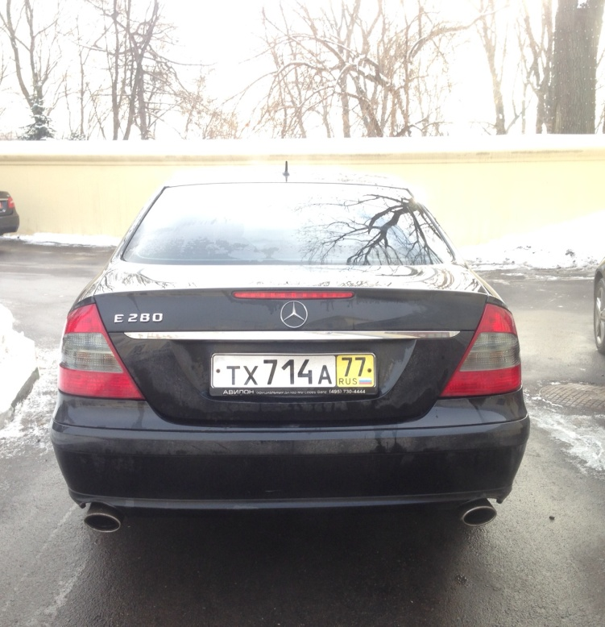
Embassy car for sale
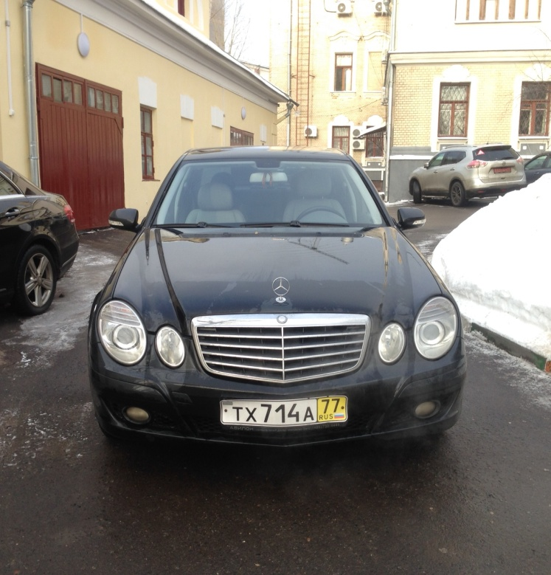
Model | Mercedes Benz E 280
Year | 2009 (Jan)
Colour | Black
Mileage | 95700
Transmission | Automatic transmission
Condition | Good
No. of Winter Tyres (Purchase Year) | 4 (Dec. 2014)

The car is not custom cleared.
Interested parties may contact the Embassy of India at the following address alongwith their offered price in a sealed cover latest by 21.02.2018:-
Counsellor (HOC),
Embassy of India,
Ulitsa Vorontsova Polye 6-8,Moscow
Phone 0+495 783 7535 Extn-333/279

